MANUAL ASSIGNMENT OF IP ADDRESSES TO COMPUTERS
EXPT:14
AIM:
To manually configure IPv4 addresses, subnet masks, and default gateways for computers in a network and verify connectivity between them.
INTRODUCTION:
In a computer network, each device must have a unique IP address to enable communication. Manual IP assignment, also known as static IP configuration, involves setting the IP address and subnet mask manually rather than automatically through DHCP. This experiment demonstrates the concept of addressing, subnetting, and basic connectivity testing using the ping command.
ALGORITHM:
- Set up network devices:
  - Place two PCs and one switch (and a router if a gateway is required) in Cisco Packet Tracer.
- Connect the devices:
  - Use Copper Straight-Through cables for the following connections:
    - PC → Switch
    - Switch → Router (optional)
- Configure IP addresses:
  - PC0:
    - IP Address: 192.168.1.1
    - Subnet Mask: 255.255.255.0
  - PC1:
    - IP Address: 192.168.1.2
    - Subnet Mask: 255.255.255.0
- Verify connectivity:
  - On PC0, open Command Prompt and type: ping 192.168.1.2
  - On PC1, open Command Prompt and type: ping 192.168.1.1

OUTPUT:
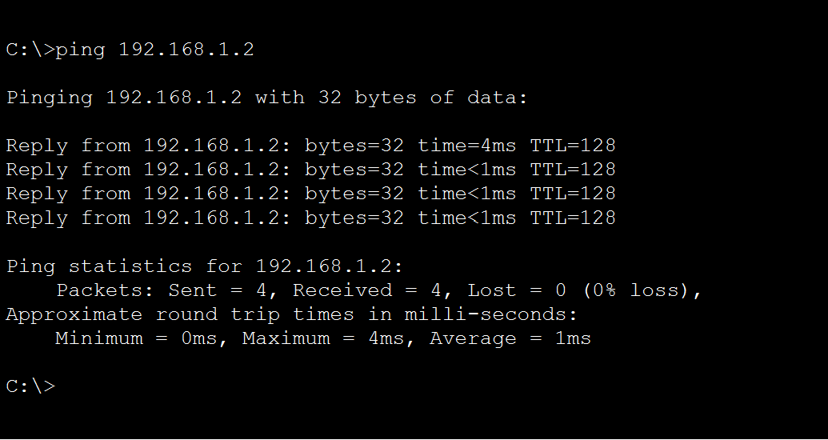

RESULT:
Static IP addresses were successfully configured on the PCs, and connectivity between the hosts was verified.

